GUEST OF THE MONTH/January 2026
Evelyn Cortez-Davis
Director of Strategic Initiatives – Water System
Los Angeles Department of Water & Power

STRATEGIC ISSUES FACING THE WATER SYSTEM IN 2026
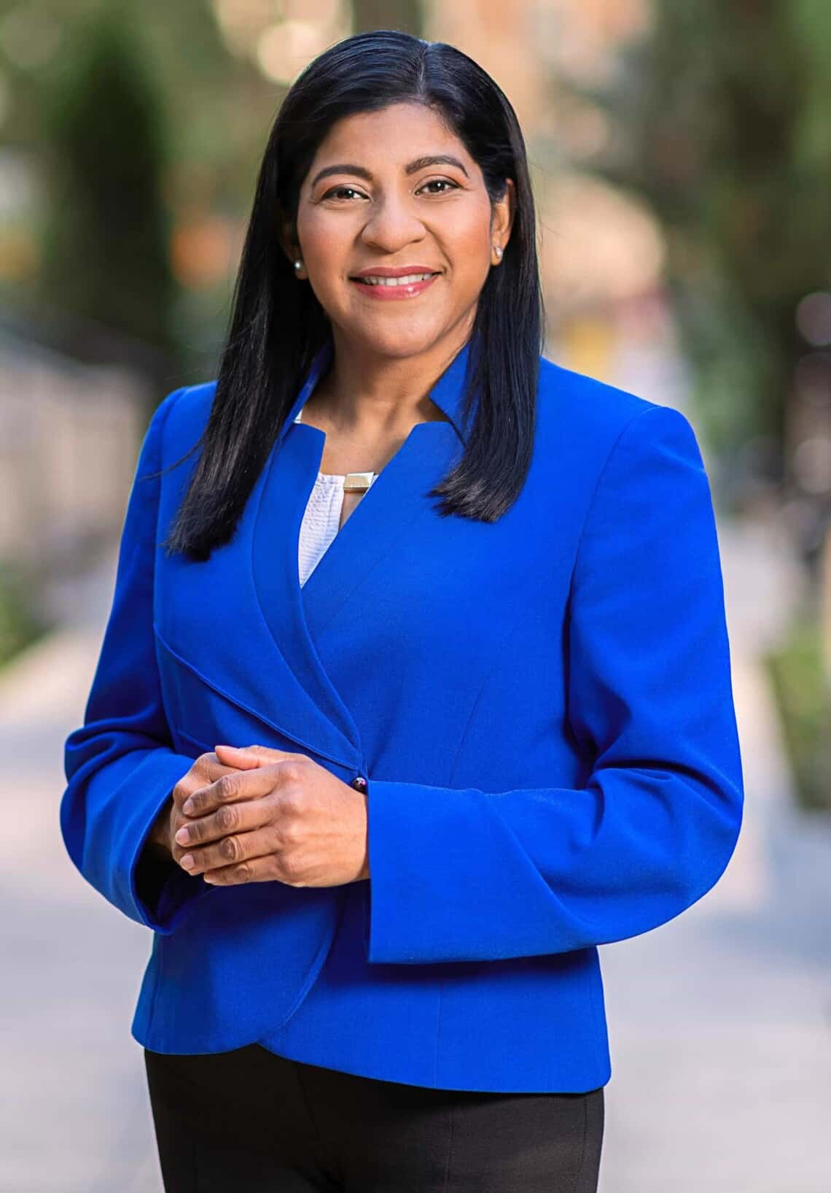
Summary by Robert Yoshimura

Evelyn Cortez-Davis began her presentation with a brief explanation of her role within the Water System. She is one of seven Director-level managers, five of whom are the heads of the traditional divisions (Water Resources, Water Quality, Water Engineering, Water Distribution, and Water Operations), plus a liaison with the Palisades fire coordinating center, and the first-ever Director of Strategic Initiatives.

Because strategic planning is an integral part of the operation of every division, her focus will be on broader initiatives that cross those division boundaries and affect all operations. For example, wildfire mitigation requires participation by every division, and she is coordinating the development of procedures that cover all aspects of wildfire mitigation. Unlike the Power System, the Water System has not yet aligned nor incorporated its standard operating procedures into the Wildfire Mitigation Plan, and such activities will be on her agenda in the coming months.

Another example is resilience planning which clearly crosses division boundaries within the Water System, and in many cases crosses System boundaries and requires integration and coordination with the Power System and other organizations at LADWP. The Water System has focused on supply resilience and infrastructure resilience for many years; however, other resiliency issues exist such as financial, regulatory, organizational, and disaster response which will require coordinated planning across the entire Department. Resilience planning needs to be long-term (longer than the 25-year horizon of the state-mandated Urban Water Management Plan) to accommodate projects such as Pure Water LA and be flexible enough to accommodate changes that may arise unexpectedly. Evelyn is now working on a framework for resilience planning that will be completed this year.

Among the cost-cutting initiatives that affect all divisions, Workforce Development will be another focal point that Evelyn will be working on with Employment Services Division. Efforts will focus on training, recruitment, and retention and will be cohesive and unified to align with organizational goals. For example, training will be designed in such a way that not only will our technical and operational needs be fulfilled but will also encourage employees to remain with LADWP for 30+ years and maximize the investment in them. Regarding recruitment, the Department has critical shortages in a number of blue-collar job categories. It is now partnering with trade schools and junior colleges to increase interest in these types of jobs and to provide appropriate pre-training that would make students better candidates for those critical jobs.

As her final topic, Evelyn discussed the Palisades wildfire of January 2025 and the actions planned or taken since then to restore service to the area and improve the water infrastructure to better serve the community in the future. She summarized those actions as described in a report titled January 2025 Wildfires – One Year Update. The full report can be found here: January 2025 Wildfires - One-Year Update. The actions summarized are as follows:

- Assessing Water Infrastructure for Resilience
- Working on a Water Resilience Plan – to be completed in 2026
- Enhancing Efficiency of Hydrant Inspections and Repairs – as of July 2025, all 61,000 hydrants in the city were inspected by the Fire Department and were quickly repaired/replaced as needed
- Continuing to Monitor and Maintain Water Quality
- Replacing 99,700 feet of water mainline pipe – a $77.7 million project to replace the oldest mainlines most at risk to leak and replacing old pipelines in areas with geological hazards with a seismically resilient network
- Upgrading an Existing Pressure Regulator Station in the Palisades
- Completed Emergency Repairs to the Santa Ynez Reservoir Floating Cover - placed the reservoir back in service
- Improving the Pumping and Water Storage Facilities in the Palisades
- Assessing Innovations and New Technologies

Evelyn is currently a team of one and additional personnel are being sought to fill out her team to accomplish these initiatives starting this year.

